PARTICIPANT’S GUIDE

Dear Guests!

On behalf of the Organizers of the Forum – «Russian Highways» State Company and Limited Liabilities Company «Avtodor – Trading Facility» - let us once again express our gratitude for your consent to take part in the Innovations in Road Construction II International Forum.
Please, read carefully this PARTICIPANT’S GUIDE, it will help you to feel free during the Forum.

- PLACE  «Pullman & Mercure Sochi Centre» | Location and Logistics  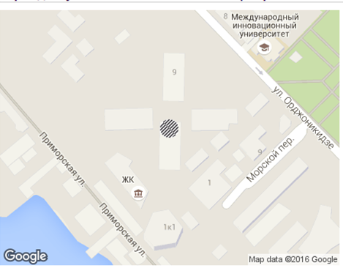
Адрес:
11а Ordzhonikidze str.
Sochi, Russia

- REGITRATION
Please, on the eve of the Forum, May 24, 2016, check the Forum Program hosted on the website http://ircforum.ru/ru/business/program/ to make sure that no changes have been made. If you have any questions feel free to contact the Organizers
Please pass the registration procedure at the registration stand. Make sure that you get badge and all the details are correct. This badge will be your pass for access to all the activities within the Forum time. The badge is valid from 25 to 27 May, 2016.

Registration schedule:
May 25, 2016: 16:00 – 22:00.
May 26, 2016: 09: 30 – 10:30.
May 27, 2016: 10:00 – 11:00.

- TRANSFER

Please, note that on May 25, 2016 the transfers from Sochi Airport will be made to the official Forum Hotel «Pullman & Mercure Sochi Centre» only.
May 27, 28, 2016 the transfers from «Pullman & Mercure Sochi Centre» to Sochi Airport will be available for the guests of the Forum.

For all the Organization matters, please contact:

Alla Egorova:
mobile: + 7 916 032 09 49
Anastasia Rebrova:
mobile: +7 926 598 30 37
Larisa Salnichenko:
mobile: +7 915 494 99 86

Looking forward to meeting you at the Forum!

