PARTNER'S GUIDE

May 25 – 27, 2016
Pullman & Mercure Sochi Centre, 11a Ordzhonikidze, Sochi

Dear Partner!

Thank you for your support and the decision to join us as «STATUS» at the II-nd International Forum "Innovations in road construction" which shall take place on May 25 – 27, 2016 in Sochi, Pullman & Mercure Sochi Centre.

Venue: Pullman & Mercure Sochi Centre, 11a Ordzhonikidze
Dates: May 25, 2016 4 p.m. – 10 p.m.
May 26, 2016 9.30 a.m. – 11 p.m.
May 27, 2016 10 a.m. – 7.30 p.m.

Contact person: Larisa Salnichenko, L.Salnichenko@avtodor-zakupki.com

Content:

- Information on the Partner's Company.
- Contract execution and payment.
- The speaker and the report presentation:
- Information on the speaker;
- Information on the report.
- Exhibition:
- Characteristics and stand equipment;
- Requirements to provision of the layout for lining.

- Presentation in WORK BOOK (forum catalog).
- Location map.
- Bringing in/ taking out the equipment.
- Checklist.
- Contact details.

Technical Requirements on Material Submission
"Information on the Company".

Please provide the information below for posting on the forum website and information materials using the FORM No. 1 / No. 2 (attached):

 | Logo in eps format curves  (Russian and English) | within 2 days of receipt of this Guidance
 | Link to the company website | within 2 days of receipt of this Guidance
 | Information on the company for website  up to 300 words  (in Russian and in English) | within 2 days of receipt of this Guidance
 | The list of participants to be posted on the forum website  (in Russian and in English) | within 5 working days of receipt of this Guidance
 | Data for making the badge | up to May 8, 2016

Contract execution and payment.

We suggest the following procedure for interaction with the organizers to participate in the forum:

- The partner shall send the details to the e-mail L.Salnichenko@avtodor-zakupki.com, indicating the contact person responsible for execution of a contract and payment.

- The organizer shall send a draft contract and invoice within 2 working days.

- The contract should be signed within 5 working days and sent to the following address: 127006, Moscow, 9 Strastnoy Boulevard, Larisa Salnichenko, tel. +7 495 727 11 95 (ext. 5915), cell: +7 968 420 73 35.

- The invoice must be paid within 10 calendar days.

- A package of closing documents (invoice, certificates, bill) shall be provided at the check-in counter on the third day of the event: May 27, 2016

- The Certificate of Completion must be sent to the following address no later than 10 calendar days: 127006, Moscow, 9 Strastnoy Boulevard, Larisa Salnichenko, tel. +7 495 727 11 95 (ext. 5915), cell: +7 968 420 73 35.

- If the account is not paid, the Partner must provide a Letter of guarantee signed by the CEO or chief accountant, bearing the seal of the organization, and specifying the terms of payment (day/month/year). In case if no warranty documents were submitted, the Organizer has the right to terminate the contract unilaterally and to invoice for the services already rendered.

The speaker and the report presentation.

For presentations of the Company representatives in the Plenary session (for the General and Strategic Partners) and in the round tables the information in the FORM No. 3 (attached) should be sent to the organizers:

Information on the speaker:

- the speaker's full name
within 2 weeks of receipt of this Guidance
- the speaker's job title:
- the speaker's portrait
photo at least 1mb: .
- the speaker's cell
(or contact person), for communication
during the event: up to May 16, 2016
- the speaker's e-mail (or contact person),
for possible updating: up to May 16, 2016

Information on the report:

within 1 week of receipt of this Guidance

- the subject of the report:
- the name of the round table:
- the theses of the report of not more than
2 pages of А4 format:
- the presentation of the report
in ppt format: up to May 20, 2016

- The organizer shall not disclose the personal data of the speaker and contact persons.

Exhibition.
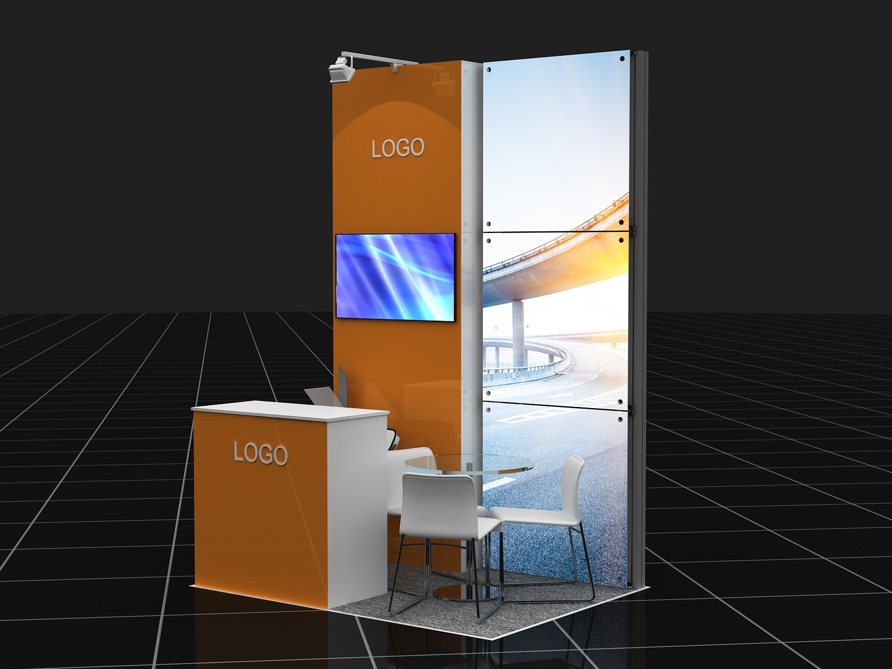

Characteristics and stand equipment: 3 sq.m. (L2xD1,5m)

- Podium with 32mm "carpet" floor covering and the LED illumination along the perimeter
- Standard construction (Octanorm h3m)
- 1х Laminated Chip Board Panel (W1xH3m) with logo
- 3х Glass Panels 980x980mm, with internal illumination, translucent film tightening (individual lining)
- 1х Laminated Chip Board Reception Stand, built-in shelf, lockable doors
- 1хLCD Monitor 42” with the ability to play video from a USB flash drive
- 1х Round Table D700mm (upon request)
- 2х Chairs (upon request)
- 1x Bar Stool
- 2x Lamps
- 1x T-joint
- 1x Brochure Holder

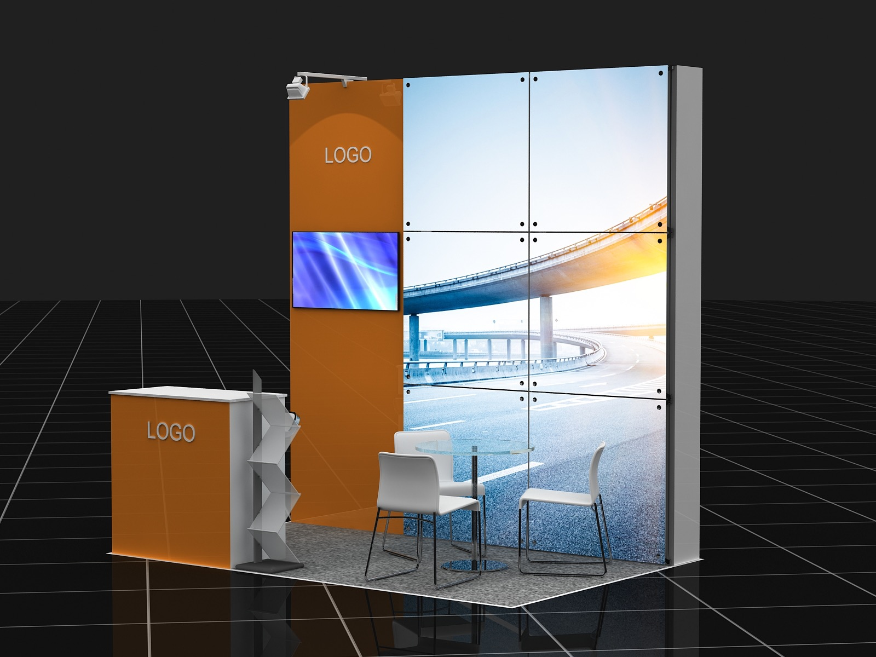

Characteristics and stand equipment: 6 sq.m. (L3xD2м)

- Podium with 32mm "carpet" floor covering and the LED illumination along the perimeter
- Standard construction (Octanorm h3m)
- 1х Laminated Chip Board Panel (W1xH3m) with logo
- 6х Glass Panels 980x980mm, with internal illumination, translucent film tightening (individual lining)
- 1х Laminated Chip Board Reception Stand, built-in shelf, lockable doors
- 1хLCD Monitor 42” with the ability to play video from a USB flash drive
- 1х Round Table D700mm (upon request)
- 3х Chairs (upon request)
- 1x Bar Stool
- 2x Lamps
- 1x T-joint
- 1x Brochure Holder
- WiFi internet access
- Tea, coffee
- 1 exhibitor category badge

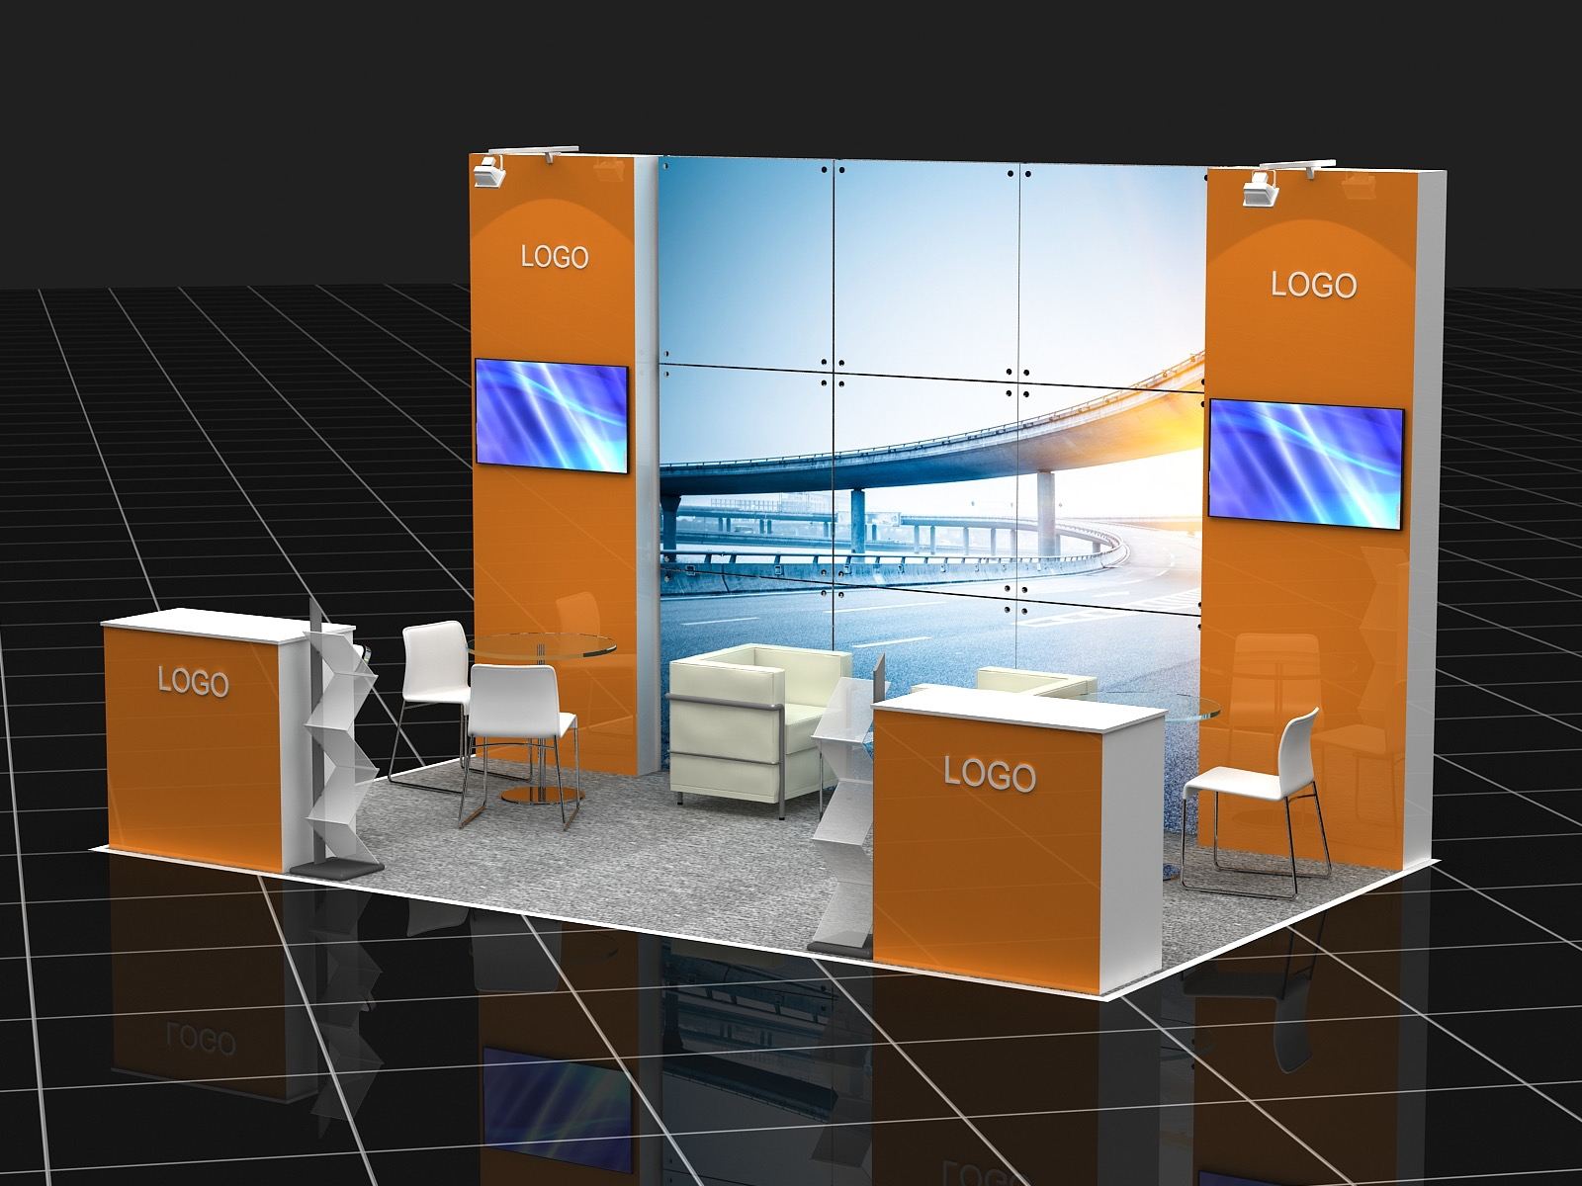

Characteristics and stand equipment 15 sq.m. (L5xD3m)

- Podium with 32mm "carpet" floor covering and the LED illumination along the perimeter
- Standard construction (Octanorm h3m)
- 2х Laminated Chip Board Panels (W1xH3m) with logo
- 9х Glass Panels 980x980mm, with internal illumination, translucent film tightening (individual lining)
- 2х Laminated Chip Board Reception Stands, built-in shelf, lockable doors
- 2хLCD Monitors 42” with the ability to play video from a USB flash drive
- 2х Round Tables D700mm (upon request)
- 2х Chairs (upon request)
- 2x Bar Stools
- 2х White Armchairs (leathercloth) (upon request)
- 1х Coffee Table (upon request)
- 4x Lamps
- 2x T-joints
- 2x Brochure Holders
- WiFi internet access
- Tea, coffee
- 2 exhibitor category badge

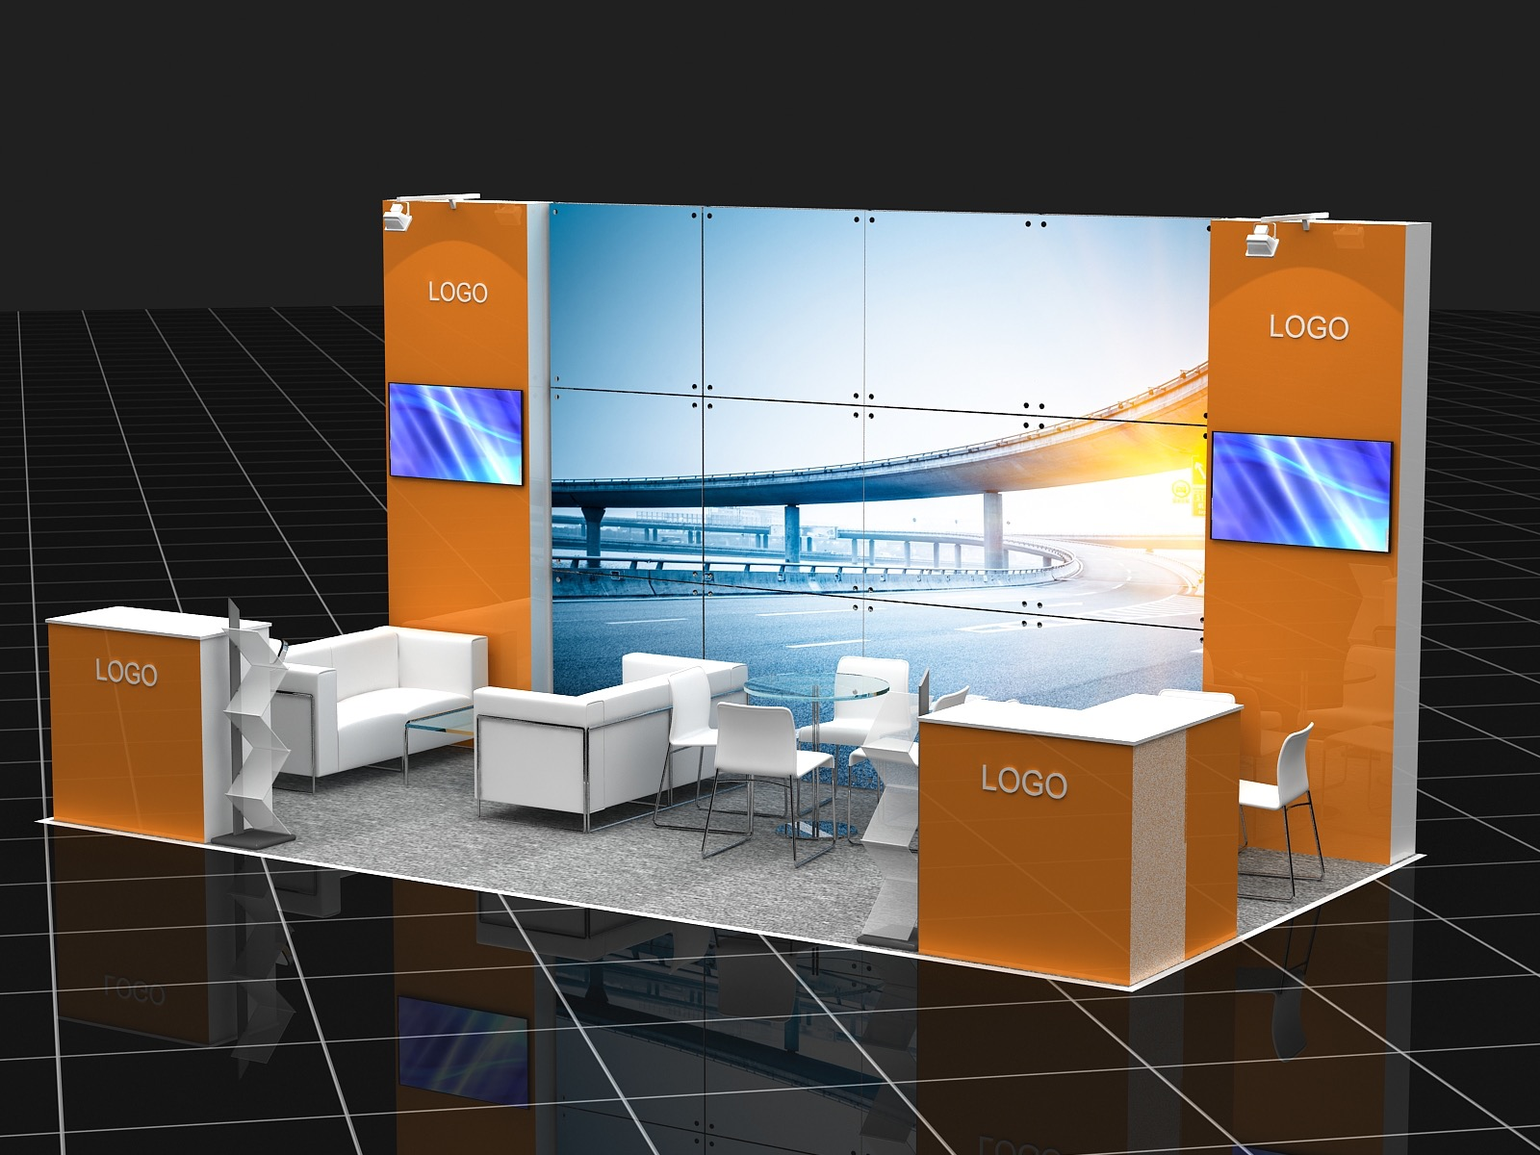

Characteristics and stand equipment: 18 sq.m. (L6xD3m)

- Podium with 32mm "carpet" floor covering and the LED illumination along the perimeter
- Standard construction (Octanorm h3m)
- 2х Laminated Chip Board Panels (W1xH3m) with logo
- 12х Glass Panels 980x980mm, with internal illumination, translucent film tightening (individual lining)
- 2х Laminated Chip Board Reception Stands, built-in shelf, lockable doors
- 2хLCD Monitors 42” with the ability to play video from a USB flash drive
- 2х Round Tables D700mm (upon request)
- 8х Chairs (upon request)
- 2x Bar Stools
- 2х White Sofas (leathercloth) (upon request)
- 1х Coffee Table (upon request)
- 4x Lamps
- 2x T-joints
- 2x Brochure Holders
- WiFi internet access
- Tea, coffee
- 2 exhibitor category badge
Requirements to provision of the layout for lining:

File formats: TIFF or PDF
Requirements to raster files:
- CMYK color model;
- All layers should be kept in a single layer — Background, without additional alpha channels, paths and LZV-compression;
- The optimal file size — up to 150 MB;
- Raster image resolution (at a size of 1:1): for image printing – 300 dpi
- In addition, you must provide your company logo in vector format (AI, CDR, EPS).

Stand:
Central panel (1 pcs) — 985х2375mm, blank space - 950х2340mm.
Side panels (2 pcs) — 985х2375mm, blank space - 950х2340mm.

- The layout for lining the stand and videos must be provided: up to May 11, 2016
- At the exhibitor's will we can provide an additional equipment at extra cost.
- If submitting graphic source later than May 11, the order can be accepted into the work insofar as its performance is possible and at extra cost.
- If submitting video later than May 11 the contractor shall not be liable for the opportunity to broadcast the content.

Presentation in WORK BOOK (forum catalog).

Please fill in the FORM No. 4 (attached).

WORK BOOK:

 | Size | Requirements | Terms
The company's advertising module  (in Russian and in English) | 2 pages А-4 | 297*210mm+ 5mm for extra-width column, eps, ai, pdf, tiff format (300 dpi) (vertical) | up to April 29, 2016
 | 1 page А-4 | 297*210mm+ 5mm for extra-width column, eps, ai, pdf, tiff format (300 dpi) (vertical)
 | 1/2 pages А4 | 148*210mm+ 5mm for extra-width column, eps, ai, pdf, tiff format (300 dpi) (horizontal)
Welcome speech of the company's chief executive, if applicable  (in Russian and in English) | Up to 200 words. | the chief executive's portrait photo 300 dpi | up to April 29, 2016

Pullman & Mercure Sochi Centre's Location Map:

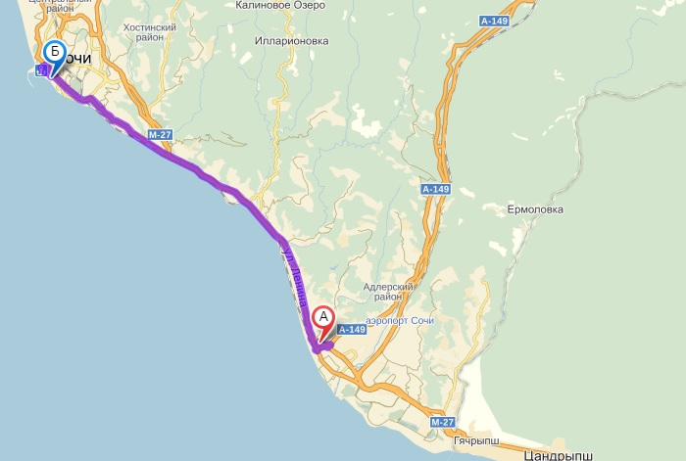

The way from Adler Airport: Pullman & Mercure Sochi Centre is 40 minutes away from Sochi airport. Drive along the M27 highway, keep driving along the Kurortny Avenue, turn left onto Poyarko Street and drive along Ordzhonikidze Street. The hotel is on your right.

Bringing in/ taking out the equipment:
To bring in/ take out the materials and equipment to the exhibition you should send the organizers a list of the units to be brought in, indicating the type and amount of equipment and the list of persons accompanying this equipment, including loaders, assemblers, drivers, etc. Besides, you should specify the contact details (cell number) of the person responsible for bringing in/ taking out the equipment in the list of the units to be brought in. You should have a copy of the list of the materials and equipment to be brought in/took out during bringing in/ taking out those ones.
The list is issued on the letterhead of the organization.
The drive in/out of the territory of the hotel is carried out according to the lists submitted to the organizers.

- A list of the equipment and materials to be brought in/took out should be submitted up to May 15, 2016

Checklist:
Item: |  | Terms: | Completed:
Information on the Company. | Logo in eps format curves  (in Russian and in English) | within 2 days
 | Link to the company website | within 2 days
 | Information on the Company up to 300 words  (in Russian and in English) | within 2 days
 | The list of participants to be posted on the event website  (in Russian and in English) | within 5 days
 | Filling data for making the badge  (in Russian and in English) | up to May 8, 2016
Contract execution and payment for participation. | Sending the partner's details, indicating the contact person | within 2 days
 | Receiving the draft contract and the invoice from the organizer | within 2 days
 | Signing and sending the contract by the partner | within 5 days
 | Payment of the invoice | within 10 days
 | Receiving the closing documents from the organizer | up to May 27, 2016
 | Returning the organizer the Certificate of Completion | within 10 days
Information on the speaker | The speaker's full name  (in Russian and in English) | within 2 weeks
 | The speaker's job title  (in Russian and in English) | within 2 weeks
 | The speaker's portrait photo at least 1mb | within 2 weeks
 | The speaker's cell (or contact person) | up to May 16, 2016
 | the speaker's e-mail (or contact person) | up to May 16, 2016
Information on the report | The subject of the report  (in Russian and in English) | within 1 week
 | The name of the round table | within 1 week
 | The theses of the report of not more than 2 pages of А4 format  (in Russian and in English) | within 1 week
 | The presentation of the report in ppt format  (in Russian and in English) | up to May 20, 2016
Exhibition | Stand approval | within 2 days
 | Provision of the layout for lining in tiff or pdf format | up to May 11, 2016
WORK BOOK  (forum catalog) | The company's advertising module  (in Russian and in English) | up to April 29, 2016
 | Welcome speech of the company's chief executive (if applicable)  (in Russian and in English) | up to April 29, 2016
Bringing in/ taking out the equipment | A list of the equipment and materials to be brought in/took out should be submitted | up to May 15, 2016

Contact details:
Project Manager:
Anastasia Leonidovna Rebrova
Tel.: + 7 495 727 11 97, ext. 5925
Cell: + 7 926 598 30 37
E-mail: a.rebrova@avtodor-zakupki.com

Sponsorship:
Dmitry Vitalievich Klimov
Tel.: + 7 495 727 11 97, ext. 5912
Cell: + 7 916 811 91 41
E-mail: d.klimov@avtodor-zakupki.com

The work with the Partner:
Larisa Viktorovna Salnichenko
Tel.: +7 495 727 11 97, ext. 5915
Cell: +7 915 494 99 86
E-mail: L.Salnichenko@avtodor-zakupki.com

The report presentation:
Alla Sergeevna Yegorova
Tel.: + 7 495 727 11 95, ext.5914
Cell: + 7 916 032 09 49
E-mail: A.Egorova@avtodor-zakupki.com

FORM No. 1

Data for making the badge

SURNAME
in Russian
in English
NAME
in Russian
in English
PATRONYMIC
in Russian

COMPANY
in Russian
in English

Please fill in this form and send it to e-mail L.Salnichenko@avtodor-zakupki.com
Contact person: Larisa Viktorovna Salnichenko, Tel.: +7 495 727 11 97, ext. 5915

FORM No. 2
The form was submitted by:
Company: | Contact person:
E-mail: | Cell:

INFORMATION ON THE COMPANY
Please fill the data in the table below:
Full name of the company
indicating the form of ownership
The company's website:
The company's e-mail
Telephone
Fax

 | IN RUSSIAN | IN ENGLISH
The company's name
Information on the Company,
up to 300 words
The company's address

Please fill in this form and send it to e-mail L.Salnichenko@avtodor-zakupki.com
Contact person: Larisa Viktorovna Salnichenko, Tel.: +7 495 727 11 97, ext. 5915

Signature and stamp |  | Full name |  | Date

FORM No. 3
The form was submitted by:
Company: | Contact person:
E-mail: | Cell:

INFORMATION FOR THE REPORT PRESENTATION
INFORMATION ON THE SPEAKER:
Please fill the data in the tables below in Russian and in English:
The company's name: | Company Name:
Full name: | Name:
Job Title: | Job Title:
Cell: | E-mail:
INFORMATION ON THE REPORT:
The subject of the report: | Topic:
The name of the round table:
The theses of the report of not more than 2 pages of  А4 format: | Abstracts of the report of no more than 2 pages  A4:

Please fill in this form and send it to e-mail:
A.Egorova@avtodor-zakupki.com
L.Salnichenko@avtodor-zakupki.com

Contact persons: Alla Sergeevna Yegorova, +7 495 727 11 95 доб.5914, + 7 916 032 09 49
Signature and stamp |  | Full name |  | Date

FORM No. 4
The form was submitted by:
Company: | Contact person:
E-mail: | Cell:

INFORMATION FOR THE WELCOME SPEECH

Please fill the data in the table below in Russian and in English:
The company's name: | Company Name:
Full name: | Name:
Job Title: | Post:
Welcome speech of the company's chief executive: | Welcoming remarks company executives:

Please fill in this form and send it to e-mail L.Salnichenko@avtodor-zakupki.com
Contact person: Larisa Viktorovna Salnichenko, Tel.: +7 495 727 11 97, ext. 5915

Signature and stamp |  | Full name |  | Date

